Synergy Zyklen

Rework of Existing Website

Allowing Independence

SWE/156/23B

GERMAN-MALAYSIAN INSTITUTE

JANUARY 2025

PROJECT TITLE OVER HERE
(Follow ikut slide)

SWE/156/23B

GROUP MEMBERS
AIN NURAIDA BINTI KHAIRULANUAR FIRHAN HARISH BIN MOHD FAIZAL
MUHAMMAD SYAHMI AFIF BIN MOHD SHAHRIRRUDDIN RAJAAHMAD AZFAR BIN RAJA BAHARUM

This project report is submitted as a partial fulfilment
of the requirement for the
Diploma in Software Engineering

PROJECT SUPERVISOR
Syamiel Amirun Aqim Bin Saarol Nizam

SOFTWARE ENGINEERING
COMPUTER & INFORMATION DEPARTMENT GERMAN-MALAYSIAN INSTITUTE

JANUARY 2025

1.0 Introduction 4
1.1 Project Background 4
1.2 Problem Statement 5
1.3 Project Objective 7
2.0 Literature Review 8
2.1 Feasibility Studies 8
3.0 Project Methodology (Refer to Discord under #text-sv -> Sharifah Nina -> Chapter 3) 9
3.1 Principal of Operation 9
3.1.1 SDLC Process 10
3.1.2 Use Case Diagram 12
3.1.3 Use Case Specification 13
3.2 Project Specification 14
3.2.1 Software Specification 14
3.2.2 Hardware Specification 14
4.0 Testing Methodology 16
4.1 Testing Model 16
4.2 Testing Tools 18
5.0 Conclusion 19

1.0 Introduction

1.1 Project Background
Synergy Zyklen Solution is a supplier and seller of consumer goods. The company has developed a unique consumer system that operates on a sequential cycle-based model, systematically tracking all product units sold, whether through the company or its consumers. The system records each individual sale according to its date and time, ensuring accurate and continuous sales tracking. Each cycle consists of a defined number of product units, with figures such as 1 to 30 units serving only as an example of how the system can be configured. The system is designed to accommodate any number of consecutive cycles, continuing automatically as long as eligible products are sold.

Currently, Synergy Zyklen, a partner of Synergy Zyklen Solution, operates through a WordPress-based website. WordPress is a free, open-source content management system that enables users to build and manage websites. It supports various plugins to extend website functionality, including back-end management, user authentication, payment processing, and other system operations. As for the cycles that the company runs on, the code was vibe coded by the manager Khairil Izad Syawal bin Kaswadi who has no background in coding.

1.2 Problem Statement
Synergy Zyklen uses Wordpress which focuses on plugins that have caused many restrictions or required extra payment to use certain features. This makes it difficult for the company to expand their business.
The cycle system which the company runs on was also vibe coded by someone without any experience in coding causing the code to be unreadable and not suitable for long term use. The code also relies on math and does not have a separate database to track ongoing cycles and relies on math which takes up resources.
Once a cycle is complete the manager needs to manually input the cash-back into the individual users wallet causing manual labor and possible errors.

1.3 Project Objective
The objective of this project is to:
- To allow the code to run independently without the use of Wordpress
- To rewrite the code for the cycle making for a cleaner code
- To allow full automation of the cycle and cash-back rewards

2.0 Literature Review
In this chapter, an overview of the important elements from past studies will be shown and briefly described. Most of these studies have been selected from few resources such as journal, article, questionnaire, and other resources that are related to this project development. This chapter will cover topics on…

2.1 Feasibility Studies

3.0 Project Methodology

3.1 Principal of Operation

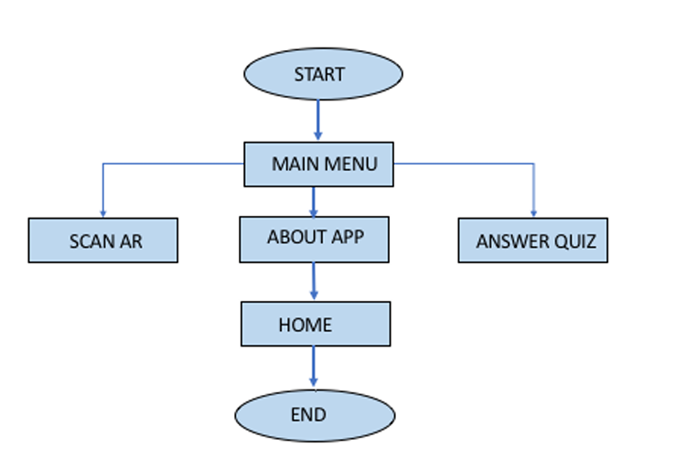
Figure ?.? Overall System Flow

3.1.1 SDLC Process

3.1.2 Use Case Diagram

3.1.3 Use Case Specification

3.2 Project Specification

3.2.1 Software Specification
Software | Detail
Table ?.? List of Software

3.2.2 Hardware Specification

Hardware | Detail
Table ?.? List of Hardware

4.0 Testing Methodology

4.1 Testing Model

4.2 Testing Tools

5.0 Conclusion

